K-Nearest Neighbors is an algorithm that is widely used to solve classification problems, as well as regressions. To solve the classification problems, we find the nearest neighbors by calculating Euclidean distance of each point by known characteristics. Below is a simplified figure of how k-NN works.
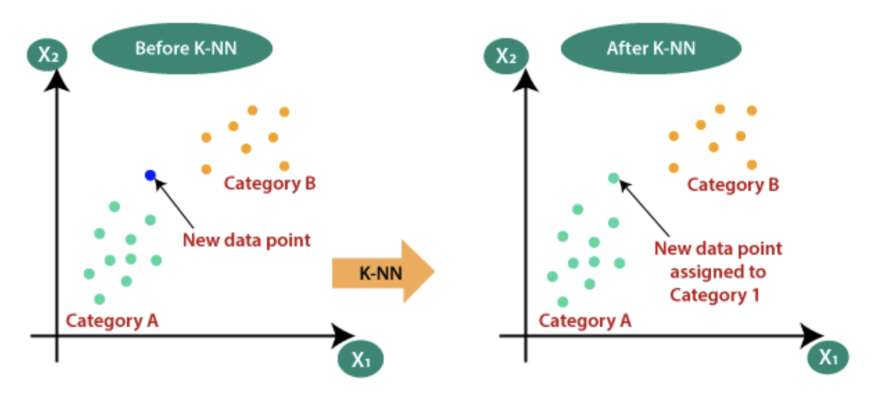
K means the number of clusters. In the figure above, the k value equals to 2. In general, choosing an appropriate k value determines the practice level of the model. Taking an overfitting k value, would ignore the nearest neighbors but to perusing the majorities. Taking an underfitting k value, on the other extreme stance, would get impacted by all the noisy data, including outliers. One simple way to decide k is the square root of the number of training data points. Another common practice is to test multiple k values from the test datasets and choose the one that fits the best. To solve the regression problems, divide the entire dataset into training and test datasets. Train k-NN “model” using the training dataset. Then apply the classifier to the test data.
In real word practice, k-NN can be used in credit card fraud detection. In this example, the datasets contain credit cards daily transactions information. Therefore, the variables include transaction amount, location, date and time, category and description, etc. The algorithm could be applied simple by looking at the locations or time. The physical transaction shouldn’t be unreasonable distance from the previous transaction, unless there was a flight ticket transaction involved. Or the transaction time mostly would be the local day time. After gathering all of these information, use k-NN to compare the dataset and detect the fraud transaction.

